Main Class Code:

public class Main

{

    public static *void* main(String[] *args*)

    {

        Circle circle = **new** Circle("MyCircle");

        circle.setRadius(10.5);

        Rectangle rect1 = **new** Rectangle("Rect1", 0, 0);

        rect1.setLength(5);

        rect1.setWidth(3);

        Rectangle rect2 = **new** Rectangle("Rect2", 2, 1);

        rect2.setLength(4);

        rect2.setWidth(2);

        Cube cube = **new** Cube("MyCube", 7);

        Shape[] shapes = **new** Shape[8];

        shapes[0] = circle;

        shapes[1] = rect1;

        shapes[2] = rect2;

        shapes[3] = cube;

        for (*int* i = 4; i < shapes.length; i++)

        {

            if (i % 2 == 0)

            {

                shapes[i] = **new** Rectangle("Rect" + (i+1), i, i);

                ((Rectangle)shapes[i]).setLength(i+1);

                ((Rectangle)shapes[i]).setWidth(i+2);

            }

            else

            {

                shapes[i] = **new** Circle("Circle" + (i+1));

                ((Circle)shapes[i]).setRadius(i);

            }

        }

        ShapeUtils utils = **new** ShapeUtils();

        System.out.println("Original shapes:");

        utils.printShapes(shapes);

        System.out.println("\nIncreasing rectangle lengths by 2:");

        utils.increaseRectangleLength(shapes, 2);

        utils.printShapes(shapes);

        System.out.println("\nChecking rectangle intersections:");

        Rectangle testRect = **new** Rectangle("TestRect", 1, 1);

        testRect.setLength(3);

        testRect.setWidth(2);

*boolean* intersects = utils.checkRectangleIntersection(shapes, testRect);

        System.out.println("Intersection exists: " + intersects);

    }

}

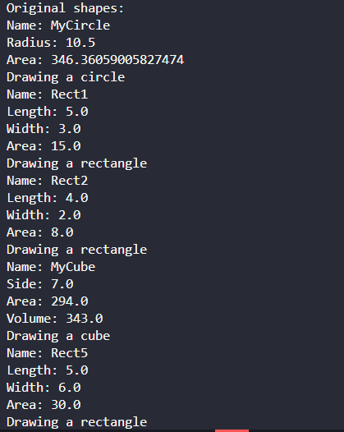Output Screenshots:

